GIT ASSIGNMENT 1
TASK 1
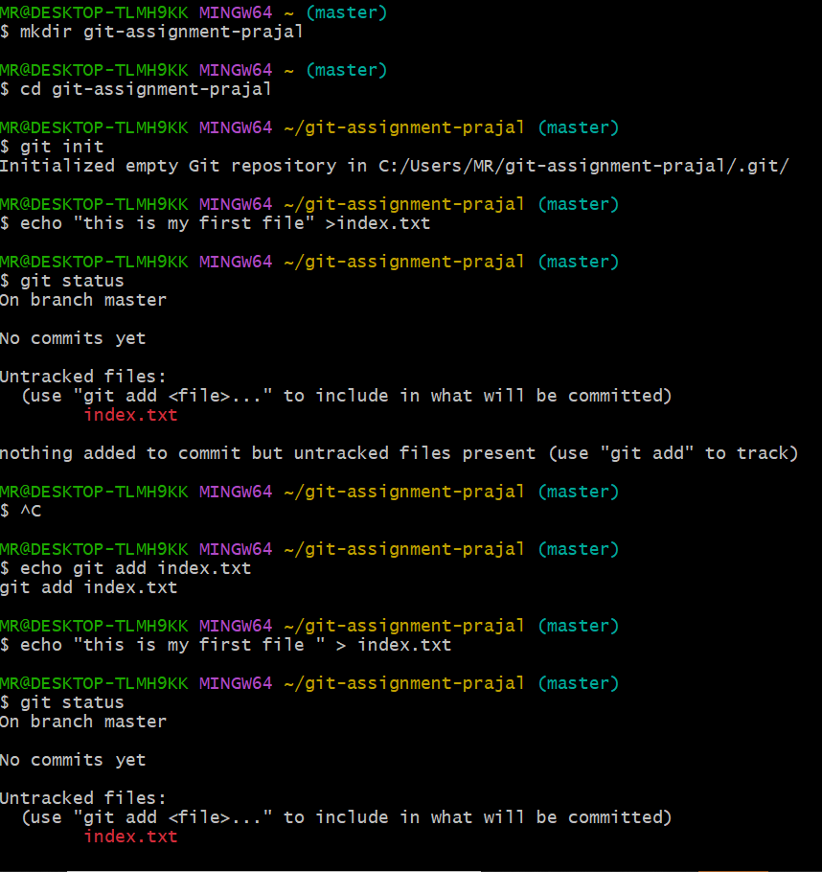

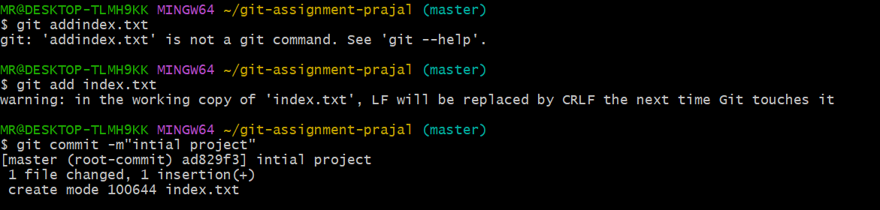

TASK 2
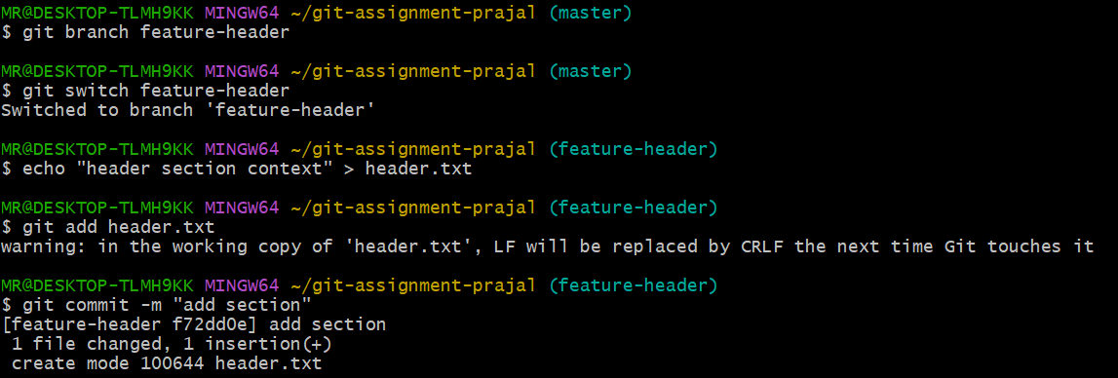
TASK 3
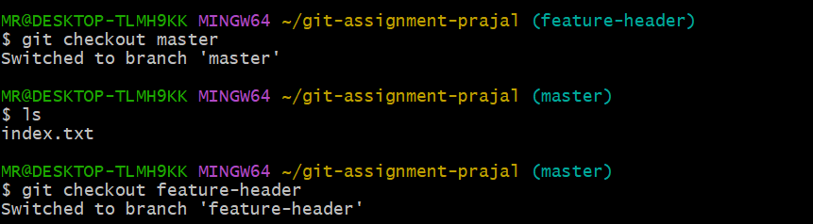
TASK 4
TASK 5

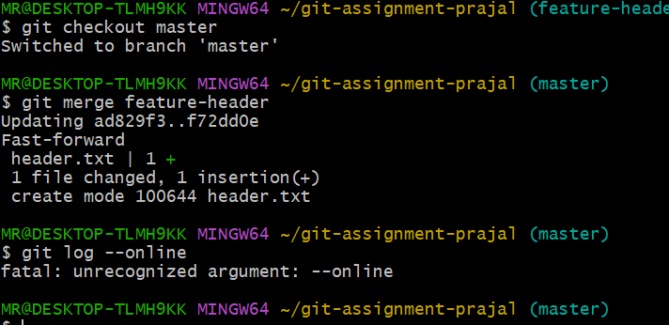
TASK 6
